Chapter 4 Asynchronous Programming
Asynchronous Programming in JavaScript
- In JavaScript, asynchronous programming is a fundamental part of the language. It is the mechanism that allows us to perform operations in the background, without blocking the execution of the main thread.

- In the browser, the main thread is responsible for updating the UI and responding to user actions.
The Asynchronous Mindset
- Asynchronous programming involves breaking down our code into small chunks and having them run in the background and then combining all the parts to achieve the desired result.

- We should adopt a non-linear way of thinking and think of what should happen next and NOT what should happen first.

There are 3 ways to write asynchronous code in JavaScript. They are:
- Callbacks: A callback is a function that is passed as an argument to another function, and it is executed when a certain event happens. The most basic way to do async operations.

- Promises: Promises are used to handle asynchronous operations in an advanced way because they use a state machine with several states (pending, fulfilled, and rejected) to keep track of operations. They’re simpler, more readable, usable and the most common way to do async ops. in modern JS.

- Async / Await: It is a wrapper to handle promise code and makes it more readable.

Understanding Callbacks (Pg- 69)
- A callback works in 2 steps: A function that is passed as an argument to another function AND the passed function is executed when a certain event happens.

- The callbacks are just a pattern where we expect that the next function to be executed is actually called as the final step (call me back when you are done - callback).

- It is important to note that the function that is passed as an argument is not executed immediately, as we only want to execute them when the operation is complete: doSomething(nextStep);

- Immediate execution will require passing the argument function with () and will produce an error. It isn’t the desired output: doSomething(nextStep()).

- Anonymous functions can also be passed as an argument. This is the most common way to use callbacks. It’s also possible to pass a function that takes arguments.

Timers and Intervals (Pg – 71)
- There are two functions that are commonly used to delay the execution of a function, setTimeout and setInterval. Both functions receive a callback as an argument and execute it after a certain amount of time.

- The setTimeout function is employed to defer the execution of a function by a specified amount of time.

- The callback is executed after the rest of the code, even though it was defined before. This is because the callback is executed asynchronously, which means that it is executed in the background, and the rest of the code are executed in the main thread.

- The setTimeout function receives two arguments. The first one is the callback, and the second one is the amount of time that the callback should be delayed. The amount of time is expressed in milliseconds.

- The setInterval function is used to execute a function repeatedly, with a fixed time delay between each execution.

- The setInterval function receives two arguments. The first one is the callback, and the second one is the amount of time that the callback should be delayed. The amount of time is expressed in milliseconds.

- The most common way to handle errors in callbacks is to use the error first pattern. This pattern consists of passing an error as the first argument of the callback, and the result as the second argument

- When many callbacks are nested together, then they become difficult to read. This is called callback hell. This can be avoided by using promises which can also be used to chain async operations together.
Mastering Promises (Pg-74)
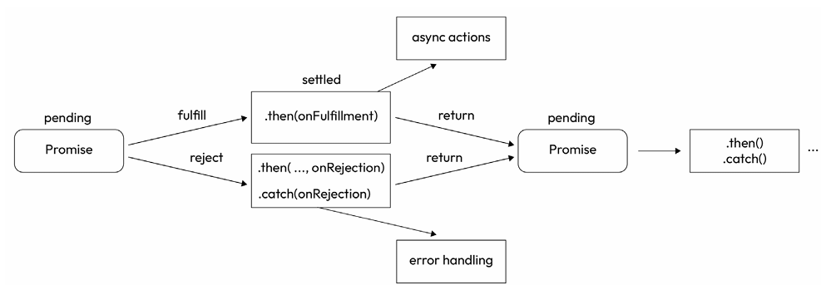
- A promise functions as a state machine, symbolizing the eventual success or failure of an asynchronous operation.

- It can exist in any of three states: pending, fulfilled, or rejected.

- After a promise is fulfilled or rejected, it becomes unchangeable. To manage fulfillment, the then method is employed, while the catch method is used to address the rejection of the promise.

Using Promises (Pg-75)
fetch('https://api.demo.foo/v1/todo')
.then(response => response.json())
.then(json => console.log(json))
.catch(error => console.log(error));
In this case, we are using the then method twice: the first time to parse the response as JSON, and the second time to print the result to the console. We are also using the catch method to print the error to the console.
Creating Promises (Pg-75)
const setTimeoutPromise = (time) => {
return new Promise((resolve, reject) => {
setTimeout(() => {
resolve();
}, time);
});
};

console.log('Before setTimeoutPromise');
setTimeoutPromise(1000).then(() => console.log('one second later'))
console.log('After setTimeoutPromise');

You can create a promise using the Promise constructor, which receives a callback as an argument. T his callback receives two arguments, resolve and reject. The resolve function is used to resolve the promise, and the reject function is used to reject the promise.
We create a function called setTimeoutPromise which takes an argument, time. In it, we are creating a Promise using the Promise constructor. In the Promise constructor, we are passing an arrow function as a callback <1>. <1> takes 2 functions as arguments: resolve and reject. Inside <1>, we are calling the setTimeout() function with 2 arguments: A callback <2> and time. Inside <2>, we are calling the resolve function.
The resolve() method resolves a given value to a Promise. If the value is a Promise, then it is returned. If the value is a Thenable, then Promise.resolve() will call the then() method with 2 callbacks it has prepared. Otherwise, the returned Promise will be fulfilled with the value.
The setTimeOut() function returns a promise that will be resolved after the given time. When the promise is resolved, then the text “one second later” will be printed.
The O/P of the above code is as follows:
Before setTimeoutPromise
After setTimeoutPromise
one second later

Parallel Promises (Pg-77)
Another advantage of using promises is that we can run multiple Promises in parallel. Basically, we provide an array of promises and we choose a strategy to handle the results. An array of Promises is provided and a strategy is chosen to handle the results: Promise.race() or Promise.all(). This is a great way to reduce the execution time, as we are using Node.js’ abilities to manage I/O operations asynchronously.
const randomTimeOutPromise = () => {
return new Promise((resolve, reject) => {
const time = Math.floor(Math.random() * 100);
setTimeout(() => {
console.log(`Promise resolved after ${time}ms`);
resolve(time);
}, time);
});
};

This function will return a promise that will be resolved after a random time between 0 and 100 milliseconds.
Promise.all(): The all method produces a singular promise that resolves once all the promises are resolved or if any of the promises are rejected.
Below, we initiate several requests in parallel and await their resolution.
Promise.all([
randomTimeOutPromise(),
randomTimeOutPromise(),
randomTimeOutPromise(),
randomTimeOutPromise(),
randomTimeOutPromise(),
]).then((results) => {
console.log("results:", results);
});

The O/P is as follows:
Promise resolved after 0ms
Promise resolved after 26ms
Promise resolved after 31ms
Promise resolved after 37ms
Promise resolved after 62ms
results: [37, 31, 26, 62, 0]

The then method will be called when all the promises are resolved, and it will receive an array with the results of each promise in the order they are being added in the promise array, not by the order in which they are resolved.
Note: If we use the all() method, we need to take into account that if a single promise generates an error, the resolved ones will be ignored just the same as if we were using a single promise.
To avoid this situation, we can use the race() method.
Promise.race(): The race method returns a single promise that is fulfilled or rejected as soon as one of the promises gets fulfilled or rejected. This can lead to unexpected results if not carefully managed, as the promises won’t stop running even if one of the promises was rejected or fulfilled already.
The then method will be called when the first promise is resolved, and it will receive the result of the first promise that is resolved. The other promises will continue running, but the then method will not be called again.

Error Handling (Pg-79)
There is another way to handle errors: using the reject function. It’s important to notice that the reject function will not stop the execution of the code, so we need to return the function after calling the reject function.
const generatePromise = shouldFail => {
return new Promise((resolve, reject) => {
if (shouldFail) {
return reject(new Error("Rejected!"));
}
resolve("Success!");
});
};

generatePromise(true).catch(error => console.log("Error message:",
error));

//O/P -> Error message: Error: Rejected!

The Promise.finally() method tells us whether the Promise has been resolved or rejected.
generatePromise(true)
.then(result => console.log("Result:", result))
.catch(error => console.log("Error message:", error))
.finally(() => console.log("Promise settled"));

Chaining Promises (Pg-80)
generatePromise()
.then(generatePromise)
.then(result => {
return generatePromise(true);
})
.then(() => console.log("This will not be called"))
.catch(error => console.log("Error message:", error));

- We can also chain promises; we can return a promise in the then method, and this promise will be resolved before calling the next then method. The catch method will be called if any of the promises in the chain are rejected.

- When the third generatePromise() is called, it will return a promise that will be rejected, so the catch method will be called and then the last then won’t be executed.

Using async and await to Handle Asynchronous Code (Pg-80)
- The async keyword is employed to define an asynchronous function, while the await keyword is used to pause and await the resolution of a promise within that function.

- Using the word async doesn’t make the code asynchronous, that will only occur when here is actual have asynchronous code in it (a promise).

- When a function is defined with the async keyword, it will always return a promise that can be handled as any regular promise.

const asyncFun = async (generateError) => {
if (generateError) {
throw new Error("Error generated");
}
return 1;
};

asyncFun().then((result) => console.log(result));
asyncFun(true).catch((error) => console.log(error));

The equivalent of writing this function w/o a promise is:
const asyncFun = (generateError) => new Promise((resolve, reject) =>
{
if (generateError) {
reject(new Error("Error generated"));
}
resolve(1);
});
asyncFun().then((result) => console.log(result));
asyncFun(true).catch((error) => console.log(error));

await (Pg-81)
The await keyword can be used to wait for promises.
// Promises
fetch(' https://api.demo.foo/v1/todo')
.then(response => response.json())
.then(json => console.log(json))
.catch(error => console.log(error));

// Async/Await
const fetchData = async () => {
try {
const response = await fetch('https://api.demo.foo/v1/todo');
const json = await response.json();
console.log(json);
} catch (error) {
console.log(error);
}
}
fetchData(); // [{userId: 1, id: 1, title: 'delectus aut autem',
completed: false}]

Immediately Invoked Function Expressions (IIFEs) (Pg-82)
- In some cases, we want to use the await keyword outside an async function, for example, when we are using the await keyword in the top level of a module. In this case, we can use an IIFE to wrap the await keyword inside an async function.

- An IIFE is a function that is executed immediately after it is created. It is a design pattern that is used to avoid polluting the global scope with variables and functions.

- The idea is to create an anonymous function and execute it immediately after it is created.

- We need to wrap the function between parentheses, and then add another pair of parentheses to execute the function.

(async () => {
const response = await fetch(' https://api.demo.foo/v1/todo ');
const json = await response.json();
console.log(json);
})()

